TO HONOR A FALLEN SOLDIER

Governor Andrew M. Cuomo has directed that flags be flown at half-staff on Tuesday, September 10th, in honor of a New York Air National Guard member who died in Afghanistan on September 5th.

New York Air National Guard Staff Sgt. Todd J. Lobraico, Jr. (age 22) died of small arms fire while on patrol outside Bagram Air Base. He was a member of the 105th Security Forces Squadron, which is an element of the 105th Airlift Wing at Stewart Air National Guard Base in Newburgh, NY. The 105th Security Forces Squadron deployed a team to Bagram Air Force Base in June to help provide security there. He was from New Fairfield, Connecticut.

“The loss of Staff Sgt. Lobraico is the first New York Air National Guard death in combat since operations began in Afghanistan in 2001. This young airman served our nation honorably and well, and we will remember him and his service with gratitude. Along with all New Yorkers, I extend my condolences to the family, friends, and comrades of Staff Sgt. Lobraico.” Governor Cuomo said.
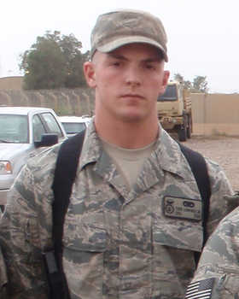
~ ~ Rest In Peace Staff Sgt. Lobraico ~ ~

